**CHAPTER 1**

**INTRODUCTION**

**1.1 Overview**

India, a country with natural beauty and historical places, is visited by many foreigners from different countries. The purpose of foreigners‟ visit to this country is diverse. The most dominant purpose is tourism. The country was listed by [Lonely Planet](http://en.wikipedia.org/wiki/Lonely_Planet) in 2011 as the "best value destination". There are some other reasons to travel the country such as political, business, official, and education purpose, and so on. However, being foreigners in India, they face some challenges during residing in the country such as lack of getting language and transport information. For meeting up some of the requirements by the travelers, we have come up with an online solution by developing android application.The chapter describes the objective of our project. Besides, it describes the scope and limitation of our system.

**1.2 Objective**

The purpose of our project is to provide the basic idea on some common conversation in the different places that the travelers need to go after coming to India. Besides, the project provides the travelers concept of transportation cost of different transport medium in the Tamil nadu city of India.

**1.3 Scope and limitation**

The scope of our project is mainly for the travelers of India. Moreover, India people particularly the new comers to Tamilnadu state can also use the application for knowing the route and source to

destination cost by different transportation medium.

Currently our project is covering only Tamilnadu region, so only travelers who visti Tamilnadu, can use the application to know the transportation information of this region.

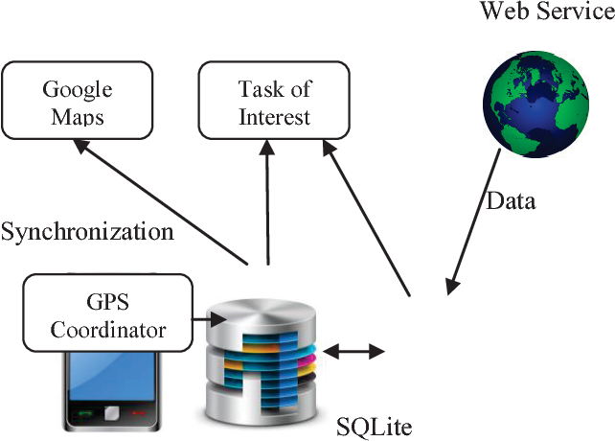

|  |
| --- |
| Figure1.1 –Google Map API |

**CHAPTER 2**

**LITERATURE REVIEW**

**2.1 Overview of travelers in India**

The number of people interested in tourism is increasing day by day. They travel to India for different purposes such as visiting, religious, job, business and so on. Statistics indicates “Tourism is the strongest and largest industry in the global economy world, generating an estimated 11% of the global gross domestic product (GDP) and employing 200 million people and serving 700 million tourists worldwide-a figure which is expected to double by the year 2020”.

**2.2 Traveler’s Requirements**

Although people can get some general information regarding traveling over the internet, it is sometimes problematic for the newcomers in a place to get familiar with the new environment. Basically, they face difficulties in communicating and finding proper routing information and associated costs for distinct routes.

2.3 Android Platform to meet the Requirements

Nowadays people have been moved so much into the modern technology that they really want an intelligent living environment along with intelligent objects which contain powerful infrastructure with the most desired features. Thus android mobile applications have become very popular among the smartphone users.

**CHAPTER 3**

**EXISTING METHODOLOGY**

**3.1 Limitation**

After evaluating our project, we have found some areas that are kept under special consideration and still need to work on. The phrases that we have developed so far are not real time interactive. Therefore, it might not be that meaningful to the target users (foreigners) as it‟s not helping them in real time conversation through language translation. Another issue is that we are not keeping track of the user‟s current location through GPS location tracker. Here in our system, a user has to provide his current location and destination to the map which is not that efficient. Furthermore, there may be different number of local buses around the city which information the user doesn‟t know but really need to know so that he/she can have the idea of local buses going to different routes.

**CHAPTER 4**

**PROPOSAL METHODOLOGY**

**4.1 Introduction to Proposed**

Considering travelers‟ requirements and popularity of android device and app, we have come up with the idea of making a mobile app for the foreigners and newcomers in one of the most attractive and tourist place in India which is named Tamilnadu, and our chosen mobile platform is Android which is open source, developed and distributed by Google.

**4.2 Architecture of the Proposed System**

The System has two types of interfaces. One is for transportation information and the other describes the phrases that are commonly used. The total architechture has been described below through fidelity prototype of the system.

**4.2.1 Fidelity Prototype**

There are two basic features of our proosed system „Travel Guide‟ except the home page. These are –

* + - 1. Home Page
      2. Phrase
      3. Search Transportation Medium

1. Home Page:

The first page of our application contains the two button named “Phrase” and “Search Transportation Medium”. Figure 4.1describes the home page.

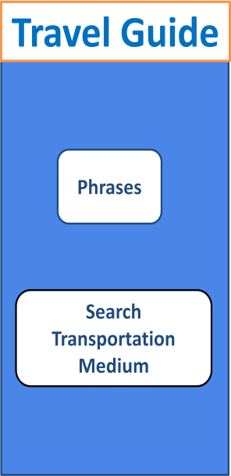 Figure4.1- Home Page

1. Phrase:

The second page of our project is called “Phrase”. This page has three buttons named “Hotel”, “Restaurant”, and “Bus”. Figure 4.2 describes this page.

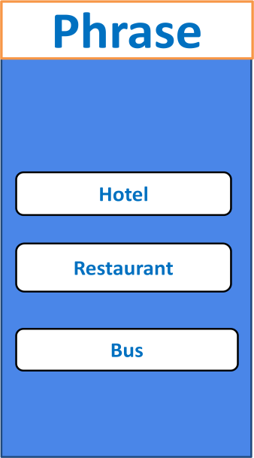

Figure 4.2 - Phrase Page

1. Search Transportation Medium:

The page will provide a google map with route from source to destination. It will also give the basic transportation cost and distance. Figure 4.3 describes this page.

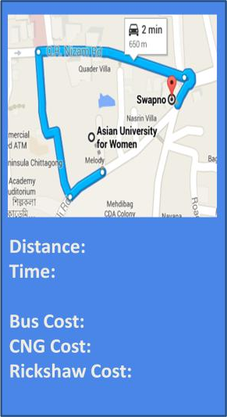

Figure 4.3-Search Transportation Medium

**CHAPTER 5**

**SYSTEM DESIGN AND DEVELOPMENT**

**5.1 Requirement Specification**

1. Functional requirements:
   * the application can show map of the city
   * map can be zoomed in and out
   * the application can show the route between different locations on map
   * giving language training
2. Non-functional requirements:
   * user interface should be usable, and easy to understand

**5.2 Android Development Tools**

Android is the significant platform for open source mobile applications. It uses Linux kernel-based as default operating system; using Android SDK to build user application in Java. Android is more flexible when it can be developed in both Mac and Windows systems Using the add-on Android SDK, we not only can develop but also can run and test the application on both of the emulators and real Android devices.

**5.3 Designing the Layouts**

First view:

This includes two buttons and the greeting for users. The buttons allow users to proceed to the new view. Phrases button - to see three different scenarios that users may meet when communicating with residents. Second button is Search transportation medium to see map and route transport info.

Phrases view:

There will be three buttons, in the order of Hotel conversation, Restaurant conversation and Bus conversation. Each subpage of these conversations is a scrollview.

Route view: GPS is implemented to automatic localization

**5.4 Developing the layouts**

Android applications uses XML layout to display its contents. Each tag in XML layout performs given property. By defining the id, these tags can be used in java code.

Main view:

Main view will have simple look using *RelativeLayout* statement for easy customizing.

Example of *RelativeLayout* statement for XML document should look like:

<RelativeLayout xmlns:android = “<http://schemas.android.com/apk/res/android>” xmlns:tools = “<http://schemas.android.com/tools>”

android:layout_width = “match_parent” android:layout_height = “match_parent”

</RelativeLayout>

Layout_width / layout_height is used to custom the view in mobile device. In this example, “match_parent” is used so the view will be as big as its parent. Layout_height is kind of similar to width but it uses vertical scale to display the view.

The child of RelativeLayout can be any view, TextView, Button, etc. In the project, TextView is used to show the name of the application and the ImageView for displaying the background. There are also two Button for menu options

ScrollView:

*ScrollView* is a special kind of layout, it‟s used to hold view that is larger than its actual size. Once the view size is larger than the *ScrollView* size, it will add scroll bar that can be scrolled vertically .

<ScrollView xmlns:android = “<http://schemas.android.com/apk/res/android>” android_width = “fill_parent”

android_height = “fill_parent” >

<LinearLayout android:layout_width="fill_parent"

android:layout_height="wrap_content" android:orientation="vertical”>

</LinearLayout>

</ScrollView>

By default, the *ScrollView* has a *LinearLayout* as its only content. However, this

*LinearLayout* can give a simple display of contents in either vertically or horizontally.

**5.5 Designing and implementing the classes**

An Activity on an Android project is the elements which interact with the user. All activities are organized in classes which place inside src folder. Every android application has MainActivity.java as the main activity class.

Main Activity

In MainActivity.java class, Intent is using to navigate to users‟ choice. An Intent is a class that is used to describe an operation to be performed. It is the primary way which helps developers start new activity within an application. It can also used as a tool to communicate between activities .

public void onClick (View v){

Intent i = new Intent (getApplicationContext(), Phrase.class); startActivity(i);

}

This method will take as parameter view which will trigger new intend. Basically, it will run code in a desired class. In this above example, this Intent will run the Phrase class once click. All the intents are defined in AndroidManifest file of the project.

<activity

android:name = “packet_name.MainActivity”

<intent-filter>

<action android:name=”android.intent.action.MAIN”/>

<category android:name=”android.intent.category.LAUNCHER” />

</intentfilter>

</activity>

For all activities, we must declare the intent filters in the manifest file.

Google Maps APIv2:

Travel Guide App uses Google Maps API v2 to execute showing the map, add markers on to map and obtain users latitudes and longitudes

In order to use Google Maps service, the application needs to register for a developer key on the Web developments. There are two main step to obtain the developer key:

First, on the tab *Windows* on *Eclipse* > *Preferences* > *Android* > *Build*, copy the SHA1 fingerprint.

Second,

follow the url: <https://code.google.com/apis/console/>On the left, go to *APIs & auth* > *Credentials* > *Create new Key* > *Android Key*. In the pop-up window, there are two pieces of information that need to fill: SHA1 fingerprint and the project package name (separated by a semicolon).

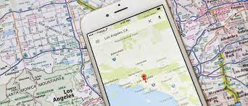

Figure 5.1–Google Map Service Sample

**CHAPTER 6**

SYSTEM SPECIFICATION

6.1 Hardware

The hardware requirements may serve as the basis for a contract for the implementation of the system and should therefore be a complete and consistent specification of the whole system. They are used by software engineers as the starting point for the system design. It shows what the system does and not how it should be implemented.

• Processor : x64 based processor

• Ram : Minimum 2Gb

6.2 Software

The software requirements document is the specification of the system. It should include both a definition and a specification of requirements. It is a set of what the systems do rather than how it should do it. The software requirements provide a basis for creating the software requirements specification.

Operating System :

Programming Language : JAVA,XML

**CHAPTER 7**

SYSTEM IMPLEMENTAION

**7.1** **Physical Features after system development**

The final outcome of the project is the online version of Travel Guide Android mobile application that contains seven pages all together which are described below.

1. Home Page:

The “Home” page is the main page that shows two options to select such as “Phrases” and “Search Transport Medium”. Figure 7.1 describes the Home Page.

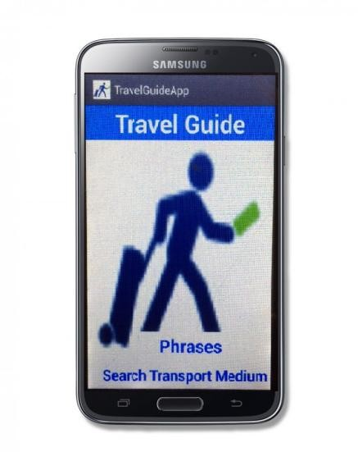

Figure7.1- Phrase Home Page

1. Phrase Page:

If someone selects “Phrases” then it leads the the person to the second page that contains the basic phrases in Bengali in three different scenarios including “Hotel”, “Restaurant” and “Bus”. Besides, the user can also listen to the audio of Bengali languages.

1. Search Transportation Medium Page

If someone selects “Search Transport Medium”, then it leads that person to the “Map” page where the user can see the map and mark his/her current location and the desired destination in order to know the transport information. As soon as he/she selects the source and destination, the map will provide the detailed routing information including distance between two places, shortest duration to be reached to the destination and finally the associated routes, for example, by bus, CNG and rickshaw. Ultimately, the user can go back

**7.2 System Evaluation and Modification**

For deploying the system, one of the member from our team who works as project manager will contact with the travel agency. The travel agency will upload our project in their website so that users can subscribe it from that.

**7.3 User Manual**

We have evaluated the system multiple times by ourself and other non-cs users who gave us feedback. Based on our parallel testing, we modified our system.

It‟s quite easy to use the application. Below are the instructions:

* + 1. Phrases:

Once tap on *Phrases* tab; there will be three options which are Hotel, Restaurant and Bus. You can select Hotel tab to learn how to conversate in Hotel, similarly for both Restaurant and Bus. Tap on the audio button to listen to the conversation in voice. The navigations at the bottom allow you to either come back to Phrase or Home page

* + 1. Routing:

Tap twice if you want to zoom-in. Select two places (your location and your destination) to put the marker.

**CHAPTER 8**

**PERFORMANCE ANALYSIS**

Satisfaction with the tour experience. Findings of Chan’s (2004) study provided the basis for hypothesizing the relationships among the three levels/layers of tourist satisfaction in this study. Hsu (2000) studied the determinants of mature travelers’ motor coach tour satisfaction and found that satisfaction with a tour guide was the strongest determinant of satisfaction with tour package.



Tour Guide Performance

Tourist Satisfaction with guiding service

Tourist Satisfaction with the Overall Tour Experience

Tourist Satisfaction with Tour Services

|  |
| --- |
| Figure 8.1–Performance flow chart |

results may not be readily applied to tour guides working in other parts of india, especially those practicing tour guiding in western regions of india that are lagging behind in economic and tourism business development.

**CHAPTER 9**

INPUT AND OUTPUT DESIGN

**9.1** **INPUT DESIGN**

The input design is the link between the information system and the user. It comprises the developing specification and procedures for data preparation and those steps are necessary to put transaction data into a usable form for processing. The design of input focuses on controlling the amount of input required, controlling the errors, avoiding delay, avoiding extra steps, and keeping the process simple. The input is designed in such a way so that it provides security and ease of use with retaining privacy.

Input Design considered the following things:

• What data should be given as input?

• How the data should be arranged or coded?

• The dialog to guide the operating personnel in providing input.

• Methods for preparing input validations and steps to follow when an error occurs.

**OBJECTIVES**

1. Input Design is the process of converting a user-oriented description of the input into a computer-based system. This design is important to avoid errors in the data input process and show the correct direction to the management for getting correct information from the computerized system.

2. It is achieved by creating user-friendly screens for the data entry to handle a large volume of data. The goal of designing input is to make data entry easier and to be free from errors. The data entry screen is designed in such a 25 way that all the data manipulates can be performed. It also provides record viewing facilities.

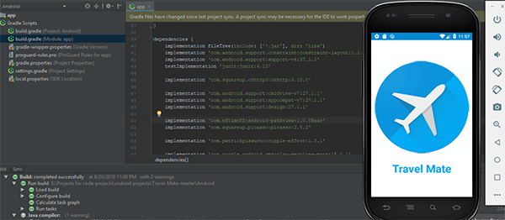

Figure 9.1 –Sample Input

**9.2 OUTPUT DESIGN**

Quality output is one, which means the requirements of the end-user and presents the information. In any system results of processing are communicated to the users and the other systems through outputs. In output design, it is determined how the information is to be displaced for immediate need and also the hard copy output. It is the most important and direct source of information to the users. Efficient and intelligent output design improves the system‟s relationship to help user decision-making.

1. Designing computer output should proceed in an organized, well thought out manner; the right output must be developed while ensuring that each output element is designed so that people will find the system can use easily and effectively. Select methods for presenting the information.

2. Create a document, report, or other formats that contain information produced by the system.

**OBJECTIVES**

• Convey information about past activities, current status, or projections of the Future.

• Signal important events, opportunities, problems, or warnings.

**CHAPTER 10**

**CONCLUSION & SCOPE OF FUTURE WORK**

Keeping travelers‟ need in consideration and the current trand to the use of android device, we have developed our Travel Guide Android Application. The application is able to meet most of the requirements that is commonly asked by the travelers, Besides, the simplicity of using the application has been maintained. The app can be helpful for Indiai people who are the newcomers to the Tamilnadu .

Based on the current limitations of our project, there can be some recommendations to improve the features of our app in order to make it more user friendly, efficient and effective as well.

Search Nearby:

Allow users to find specific places such as hotels, restaurants, book stores near their current geographic location.

**Real Time Interactive Conversation:**

The conversation in hotels, buses and restaurants are to be real time interactive through instant language translations.

GPS Location Tracker:

Instead of giving user‟s current location to the map, the user‟s location will be automatically followed by GPS location tracker which will make the app more powerful and systematic.

# APPENDIX 1

**SAMPLE OUTPUT**

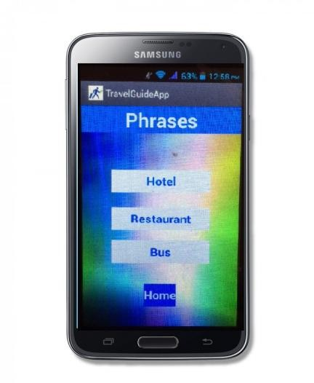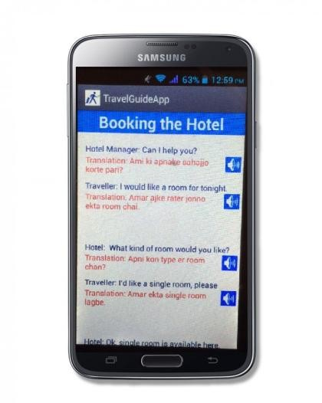

Figure A1.1 -Hotel Home Page

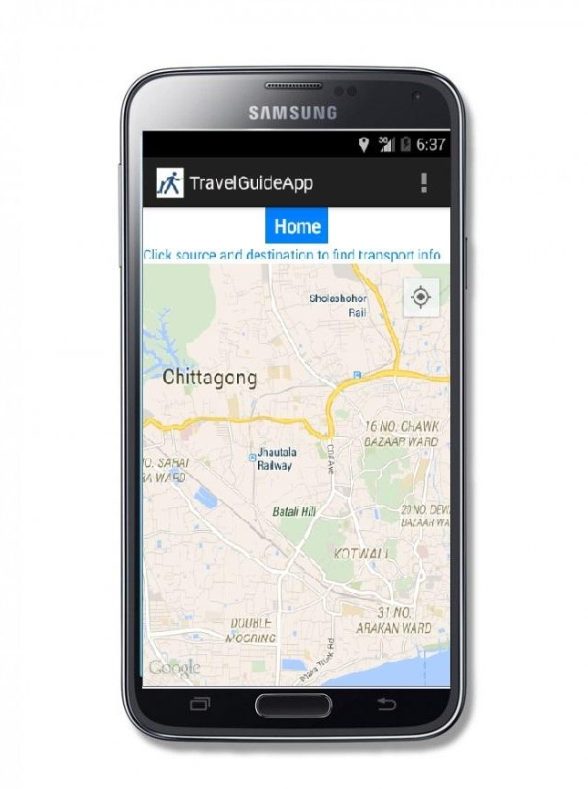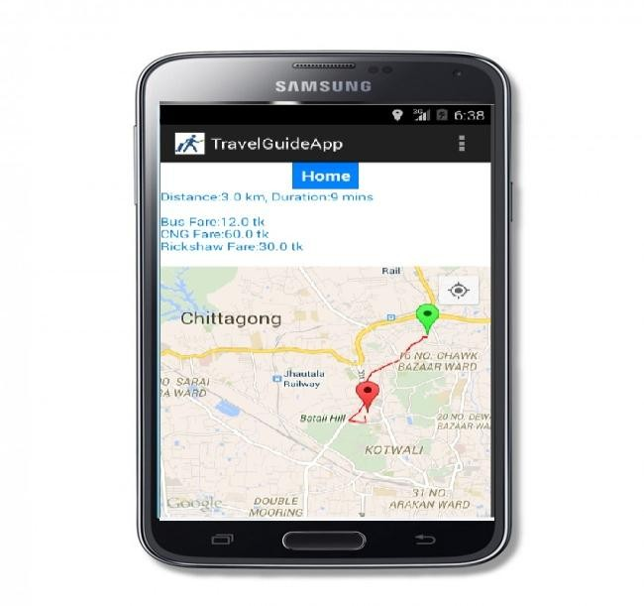

Figure A1.2 –Route Map

# APPENDIX 2

**SAMPLE CODE**

<?xml version=*"1.0"* encoding=*"utf-8"*?>

<manifest xmlns:android=*"*[*http://schemas.android.com/apk/res/android"*](http://schemas.android.com/apk/res/android)package=*"com.example.travelguideapp"*

android:versionCode=*"1"* android:versionName=*"1.0"*

>

<uses-sdk android:minSdkVersion=*"17"* android:targetSdkVersion=*"19"* />

<uses-permission android:name=*"com.example.travelguideapp.permission.MAPS_RECEIVE"* />

<uses-permission android:name=*"android.permission.INTERNET"* />

<uses-permission android:name=*"android.permission.WRITE_EXTERNAL_STORAGE"* />

<uses-permission android:name=*"com.google.android.providers.gsf.permission.READ_GSERVICES"* />

<uses-permission android:name=*"android.permission.ACCESS_COARSE_LOCATION"* />

<uses-permission android:name=*"android.permission.ACCESS_FINE_LOCATION"* />

<uses-permission android:name=*"android.permission.ACCESS_NETWORK_STATE"* />

<uses-permission android:name=*"android.permission.INTERNET"*/>

<permission android:name=*"com.example.travelguideapp.permission.MAPS_RECEIVE"* android:protectionLevel=*"signature"* />

<uses-permission android:name=*"com.example.travelguideapp.permission.MAPS_RECEIVE"* />

<uses-permission android:name=*"android.permission.INTERNET"*/>

<uses-permission android:name=*"android.permission.WRITE_EXTERNAL_STORAGE"*/>

<uses-permission android:name=*"com.google.android.providers.gsf.permission.READ_GSERVICES"*/>

<uses-permission android:name=*"android.permission.ACCESS_COARSE_LOCATION"*/>

<uses-permission android:name=*"android.permission.ACCESS_FINE_LOCATION"*/>

<uses-feature

android:glEsVersion=*"0x00020000"* android:required=*"true"*/>

<application android:allowBackup=*"true"*

android:icon=*"@drawable/ic_launcher"* android:label=*"@string/app_name"* android:theme=*"@style/AppTheme"* >

<activity android:name=*"com.example.travelguideapp.MainActivity"* android:label=*"@string/app_name"* >

<intent-filter>

<action android:name=*"android.intent.action.MAIN"* />

<category android:name=*"android.intent.category.LAUNCHER"* />

</intent-filter>

</activity>

<activity android:name=*".Phrase"*

android:label=*"@string/app_name"* >

<intent-filter>

<action android:name=*"android.intent.action.Phrase"* />

<category android:name=*"android.intent.category.DEFAULT"* />

</intent-filter>

</activity>

<activity android:name=*".Hotelpage"*

android:label=*"@string/app_name"* >

<intent-filter>

<action android:name=*"android.intent.action.hotelpage"* />

category android:name=*"android.intent.category.default"* />

</intent-filter>

</activity>

<activity android:name=*".Hotelpage1"*

android:label=*"@string/app_name"* >

<intent-filter>

<action android:name=*"android.intent.action.hotelpage1"* />

<category android:name=*"android.intent.category.default"*/>

</intent-filter>

</activity>

<activity android:name=*".Hotelpage2"*

android:label=*"@string/app_name"* >

<intent-filter>

<action android:name=*"android.intent.action.hotelpage2"* />

<category android:name=*"android.intent.category.default"*/>

</intent-filter>

</activity>

<activity android:name=*".Restaurantphrase"* android:label=*"@string/app_name"* >

<intent-filter>

<action android:name=*"android.intent.action.Restaurantphrase"* /><category android:name=*"android.intent.category.DEFAULT"* />

</intent-filter>

</activity>

<activity android:name=*".Restaurantphrase2"* android:label=*"@string/app_name"* >

<intent-filter>

<action android:name=*"android.intent.action.Restaurantphrase2"* />

<category android:name=*"android.intent.category.DEFAULT"* />

</intent-filter>

</activity

**REFERENCE**

1. R. Siddiqi, 'Bangladesh Monitor', *Bangladeshmonitor.net*, 2015.[Online].Available:[http://www.bangladeshmonitor.net/news_detail.php?nhid=2135&CID=1.](http://www.bangladeshmonitor.net/news_detail.php?nhid=2135&CID=1) [Accessed: 11- May- 2015].
2. S. Li, *Food Phone Application* . cs.sjsu.edu, 2010, pp. 1-40.
3. DELOUCHE and P. TSNOBILADZE, *Dynamic Music Creation on a Smartphone*. sonoscaphes.com, 2013.
4. Y. Dzezhyts, *Android application development*. Haaga Helia, 2015, pp. 1-40.
5. Iversen and M. Eierman, *Learning Mobile App Development*. Pearson Education, Inc, 2013, pp. 1-350.